

Functional Area: CSA Portal Login

Screen Specifications

Document History
Version | Date | Description | Name
0.1 | 15/02/2006 | Initial draft | Nicholas Cole
0.2 | 19/02/2006 | Reviewed with the business.  Screens for Login, Locate Customer and Delete MTM account have been baseline. | Nicholas Cole
0.3 | 19/02/2006 | View Audit History Added | Nicholas Cole
0.4 | 23/02/2006 | Split out from whole system screen specification.  Baseline by Business | Nicholas Cole
0.5 | 23/03/2006 | Excalibur password validation updated | Nicholas Cole
0.6 | 24/03/2006 | Business data to domain model mapped | Alexander Fyodorov

1.1.1 Screens 3
1.1.1.1 Screen – CSA Portal Login 3

Screens

Screen – CSA Portal Login
The purpose of this screen is to gather user’s login credentials (username and password) to log in to CSA Portal.

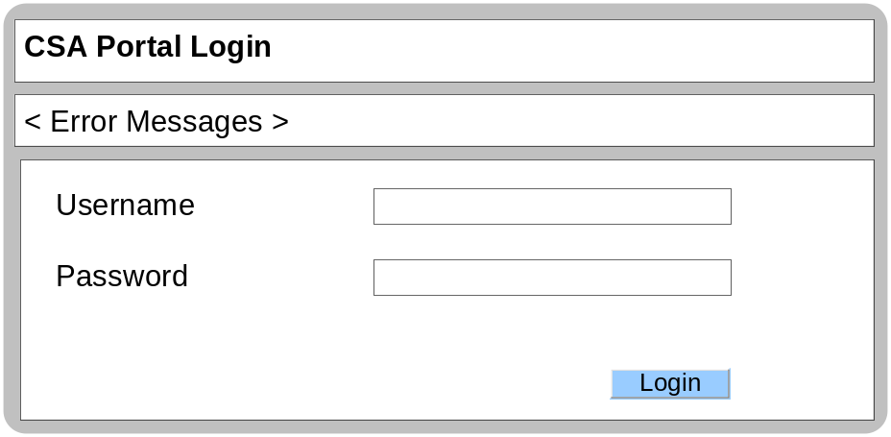

Business Logic Content
Name | Type | Description/Condition
CSA Portal Login | Screen Title | The title of the screen
Error Messages | Dynamic Text | The Error Messages will be displayed if any of the validation rules are not met.  If any of the mandatory fields are null:  Error Message = “Please complete the mandatory fields.”  If the username or password are incorrect:  Error Message = “Incorrect username or password, please try again.”
Username | Data Entry Field | The username field will capture CSA Portal username.  This field is mandatory  Default value is empty on entry  Min = 7 characters. Max = 9 characters  Numeric characters only
Password | Data Entry Field | The password field will capture CSA Portal password.  This field is mandatory  Default value is empty on entry  Min = 8 characters. Max = 20 characters  Must contain at least one upper case / one lower case / 1 numeric  The first and last has to be a letter

Links
Name | Destination | Description/Condition
Log In | Landing page | Leads user to Landing page when login has been successful
Log In | CSA Portal Login | Leads user to CSA Portal Login screen when login has been unsuccessful

Validation
Name | State / Response
Username & Password | The system will validate the entered username and password combination. The result of the validation will dictate which screen will be displayed to the user.

Domain Model

Field | Domain Model Name
Username | login.CSAPortalUser.userId
Password | login.CSAPortalUser.password

